St. Patrick Parish
Faith Formation Ministry
140 Church St.
Portland, MI 48875
517-647-6505 Ext. 419
MondayNightFaithFormation
February 2020
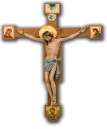
This Photo by Unknown Author is licensed under CC BY-NC

Month of the Passion of Our Lord
Every deed of Christ is a cause of glorying to the Catholic Church, but her greatness of all glorying in is the Cross; and knowing this, Paul says, But God forbid that I should glory, save in the Cross of Christ. For wonderous indeed it was, that one who was blind from his birth should receive sight in Siloam: but what is this compared with the blind of the whole word? A great thing it was, and passing nature, for Lazarus to rise again on the fourth day; but the grace extended to him alone, and what was it compared with the dead in sins throughout the world. Since the Passion of the Lord portrays Jesus’ death on the cross, I am challenging the students to bring in any type of Crucifix that you might have in your home. This can be a necklace, bracelet, small one, on a key chain, or a picture. Prizes will be given out to those who participate.

Stations of the Cross
This year Ash Wednesday is February 26th which will begin the Lenten Season. This season last 40days. During this time we are reminded of the sufferings Jesus endured for us. Stations of the Cross and Soup Suppers are each Friday during this time. Each week different Ministries are asked to provide services on these Fridays. The Faith Formation Ministry is scheduled to do so on Friday, February 28th. Volunteers readers are needed and all families are asked to provide the soups and breads for the supper. Mark your calendar now and more information with details will be sent out soon.
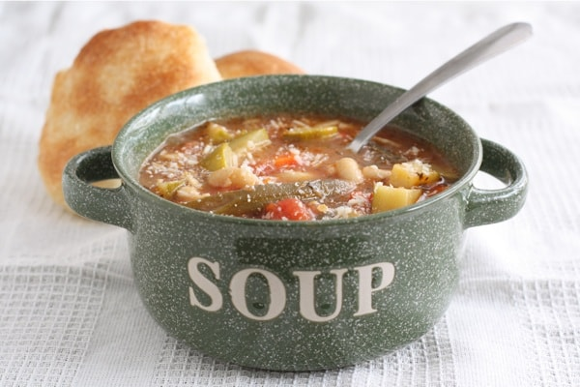

PSIC-Baby Bottle Challenge
This service project is well on its way. The students have donated a total of $215.86 for the month of January. The 2nd grade class made the most change in an infant life by providing them with $72.02. They will be rewarded with their choice. Thank you to all who sacrificed to help change the lives of others. The challenge will start over in February, so keep collecting to change lives.

First Communion Information
All Mass celebrations have been scheduled. An email was sent out with your child’s Mass date and time. If you did not receive this, please contact me right away. If for some reason you need to change or reschedule your Mass, please contact me right away. I will be sending out more details the closer the dates get here.
This Photo by Unknown Author is licensed under CC BY-SA

Calendar of Events

February 2020 March 2020 2nd-(SUN) Confirmation Prep Session (1-2:30pm) 1st- (SUN) 2nd & 8th Sacramental Prep Sessions 3rd -Classes (Rosary 7:30 pm) (6:30-8:00pm)
9th-(SUN) Confirmation Prep Session (1-2:30pm) 2nd -Classes (Rosary 7:30pm)
10th- Classes/CONGO Meals 4-6pm 8th- (SUN) 2nd & 8th Sacramental Prep Sessions
17th- NO CLASSES (Mid-Winter Break) (6:30-8:00pm)
23rd-(SUN) Confirmation Prep Session (1-2:30pm) 9th- Classes/CONGO Meals 4-6pm
24th - Classes
28th-(FRI) Stations of the Cross/Soup Supper 16th - NO CLASSES (Catechist In-Service)
(6 pm) 22nd- (SUN) 2nd & 8th Sacramental Prep Sessions
(6:30-8:00pm)
23rd -Classes
29th- (SUN) 2nd & 8th Sacramental Prep Sessions
(6:30-8:00pm)
30th- Classes

“Even now, says the Lord, return to me with your whole heart, with fasting, and weeping, and mourning: Rend your hearts, not your garments, and return to the Lord, your God.”
(Joel 2:12-18)

