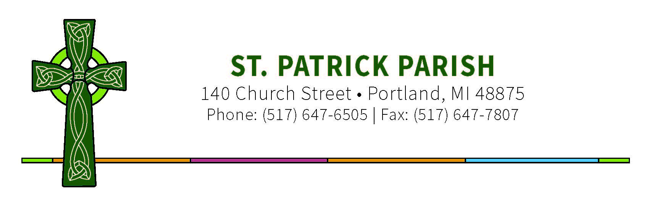

March 1, 2020

Dear Confirmation Candidates, Parents, and Sponsors,

Confirmation for the 8th graders preparing for this Sacrament will take place on Sunday, May 3rd at 3:00 pm at St. Andrew Cathedral, Grand Rapids. The Diocese has asked us to supply some volunteers for the Confirmation Mass, such as Extraordinary Ministers of Holy Communion, Ushers, Lector, and Altar Servers. If there are any parents, siblings, extending family members, or Sponsors from our parish that would consider any of these opportunities, please give me a call. Need to sign up volunteers now, and I can do that for you.

For the Confirmation Liturgy, Candidates and Sponsors will need to be settled in their pews by 2:30pm. It would be good to plan on arriving at the Cathedral before 2:30pm. When you arrive, you will receive from me a name tag with your Confirmation name in it that you will need to wear during the Mass and Confirmation Rite.
When the Sponsor and Candidate are standing in front of the Bishop, the Sponsor is tell to the Bishop the Candidate’s CONFIRMATION NAME. Final instructions will be given to Candidates and Sponsors before the Mass begins.

The address of the Cathedral of St. Andrew is 265 Sheldon Blvd. SE, Grand Rapids, MI 49503. It is located one block east of Division Ave. and about 3 blocks south of Fulton St. on Sheldon. Map with directions is attached.

Please remember that Confirmation is a special sacramental celebration and that Candidates should dress appropriately. The guidelines for dress from the Diocese is attached.

If you or any family members need handicap accommodations, please contact me as soon as possible.

Any questions or concerns, please contact me anytime.

God Bless,

Lori Thelen
Coordinator of Children’s Faith Formation
517-647-6505 x 419

