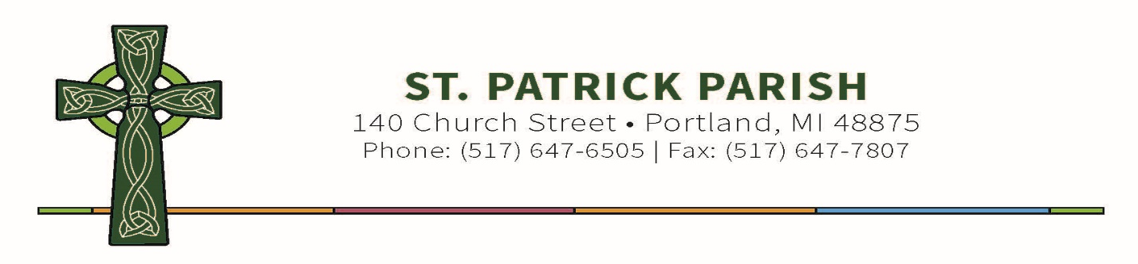

Dear Second Grade Parents,
Attached you will find two important pieces of information regarding your child’s First Communion.

First is the directions to the online “Signs of Grace: You Are Forgiven” program. This is straight from Augustine Institute. Use this link to have access to the course https://sacraments.augustineinstitute.org/enroll/882003?th__ug=30a1a2ce&th__c=stpatrick-mi-48875-yaf Do not redeem the coupon link more than once for each student.

If you should have login or other technical issues after registering, you should contact: customer.service@augustineinstitute.org

Second is the course outline to follow week to week. Following this outline will help guide you through the course to ensure completion in time for your child to receive the Sacrament of Reconciliation.

We are looking forward to help prepare your child for this Sacred Sacrament.

You have our prayers for your child and family in this blessed time.

God Bless,

Lori Thelen
Coordinator of Children’s Faith Formation
Coordinator of Safe Environment
St. Patrick Parish
517-647-6505 Ext. 419

