St. Patrick Parish
Faith Formation Ministry
140 Church St.
Portland, MI 48875
517-647-6505 Ext. 419
MondayNightFaithFormation
November 2020

Month for Holy Souls in Purgatory
The church commemorates all her faithful children who have departed from this life, but have not yet attained the joys of heaven. St. Paul warns us that we must not be ignorant concerning the dead, nor sorrowed, “even as others who have no hope…For the Lord Himself shall come down from heaven…and the dead who are in Christ shall rise.” The church has taught us to pray for those who have gone into eternity. I challenge families to talk about their loved ones who have passed. Discuss any memories you may have. Talk about something that was given to you by a deceased member of the family. Give each member a turn at this.

Generosity
“A person who is uncomplaining under pain and disappointment”. Parents are to teach and challenge their children this throughout the month. However you choose to reward them for practicing this is up to you. If you contact me that your children were “caught in the act” displaying this, I will send them free Slushie cards.

First Reconciliation Preparation
All second-grade parents should have received information regarding your child’s preparation for receiving this Sacrament. Students should also be on week #2 in the “Signs of Grace” online program. If you are having any issues with this, please contact me right away. In the past Father has scheduled a couple of dates for the children to receive Reconciliation, we are still working this out. You will receive all information needed in time.
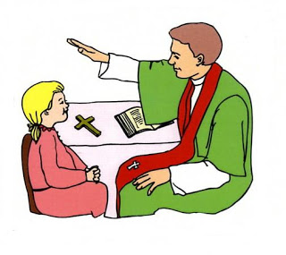
Forgiveness is the foundation for Reconciliation
Service Project for November
This month’s service project will be to donate to the food bank. As a family you are to gather food and drop it off directly to the Portland Food Bank located in the Senior Center on Kent St. They are open every day until 3:30 pm. Below is a list of what each grade level is to donate. This is to make sure there is a variety of food donated. Please consider being generous and donate what you can.
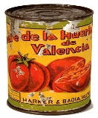
This Photo by Unknown Author is licensed under CC BY-SA
DK/K -Macaroni & Cheese, potatoes in a box, cereal, Jell-O
1st Grade- Canned fruits, juices, tuna, stuffing mix, applesauce
2nd Grade -Canned vegetables, chicken gravy, baby food, popcorn
3rd Grade- Spaghetti, spaghetti sauce, canned stew, powdered milk
4th Grade- Tomato products, refried beans, Fruit cocktail, granola bars
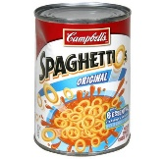
5th Grade- Syrup, cookie, rice, coffee, pie mix, pie filling
6th Grade -Peanut Butter, jelly, flour, cake mixes, frosting
7th Grade -Hamburger Helper, cooking oil, pancake mix, crackers
8th Grade- Soups, sugar, canned sweet potatoes, chicken both
If you contact me with the total number of food items your family has donated throughout the month you will be rewarded.

“Let us give thanks to the Father, who has made you fit to share in the inheritance of the holy ones in light.”
(Colossians 1:12-20)

