St. Patrick Parish
Faith Formation Ministry
140 Church St.
Portland, MI 48875
517-647-6505 Ext. 419
MondayNightFaithFormation
December 2020

Month for Devine Infancy
December is dedicated to the Devine Infancy. For there to be a “Devine Infancy” there must be an Infant who is God. For that infant to be known as an infant by us, He must be of our own ken-a man like us. In other words, if we do not see the baby, we will not know the Baby; if we do not see the boy, we will not know that boy. Thus, for there to be a month of Devine Infancy, there must first have been the Mystery of the Incarnation, the Mystery of the God-made-man. There is no December 25 without March 25. So, for December I challenge the parents to discuss with their children about them as a baby. What are some of your fondest memories of them as a baby? Tell your children some memorable stories.

Compassion
“Have feelings or showing sympathy & concern for others”. Parents are to teach and challenge their children this throughout the month. However you choose to reward them for practicing this is up to you. If you contact me that your children were “caught in the act” displaying this, I will send them free Slushie cards.

First Reconciliation Preparation
All second-grade parents should have received information regarding your child’s preparation for receiving this Sacrament. Students should also be on week #7, last session(Dec. 6th), in the “Signs of Grace” online program. If you are having any issues with this, please contact me right away. In the past Father has scheduled a couple of dates for the children to receive Reconciliation, we are still working this out. You will receive all information needed in time.
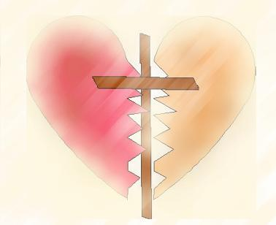
“And help me to have the love, grace, and
wisdom to pursue reconciliation”

Confirmation Information
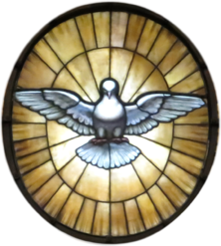
Information for preparation for this Sacrament will be sent out later this week. If you do not receive it, please let me know. This year’s preparation will be done using the “Chosen” online program from Ascension Press. There are twelve lessons that the students will need to complete. There will be an outline to follow to help guide students through this process. It should not be difficult to complete one lesson in one week’s time. Sponsor information will also be sent out. This Sacrament will be celebrated here with Father Mike next Spring/Summer. This will not be known until late Spring 2021. You will receive all information in time.

Service Project for December
This month’s service project will be to make Christmas cards for our homebound Parishioners. There are boxes at the entrances of the church to place the cards in. Below are the names those cards can be made for.

Ann Van Allen
Barb Densmore
Bev Fedewa
Bill Pintal
Connie Owen
Don Kavanaugh
Donna Fedewa
Eleanor Peake
Ernie Root
Felix Hernandez
Gary Hodge
Geri Ryan
Ginger Lehman

Greg Bailey
Harold Zoll
Helen Cook
Irene Jensen
Jane Gross
Janette Kramer
Jim Owen
John & Marge Moyer
JoAnn Spitzley
Laura Stegenga
Linda Schanski
Mary Richards

Monica Bartlett
Patrick Trierweiler
Richard Breimayer
Rosalie Sochor
Sandra Odom
Sandy Hornby
Shirley Dorsky
Theresa Gerkman
Tom Keilen
Rosemary Pung
Virginia Luna
Michelle Huhn
Marilyn Smith
Mike & Jane Huhn

If you contact me with the total number of cards your family has made between now and December 6th you will be rewarded.

“Jesus said to his disciples: “Be watchful! Be alert! You do not know when the time will come.”
(Mark 13:33-37)

