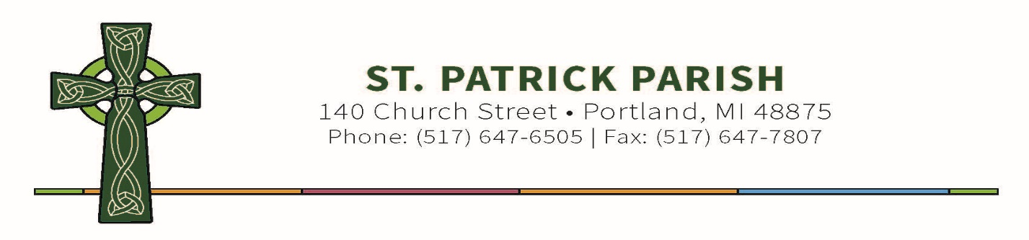
February 25, 2021
Dear Parents of Eighth Graders,
This year your student will begin the process of preparing to receive the Sacrament of Confirmation. We joyfully look forward to facilitating this opportunity for you and your student to have a more deeply encounter with Christ!
This preparation is for all students who are registered members of St. Patrick Catholic Church. As mentioned in a previous letter, preparation will occur at home through the online “Chosen” program from Ascension Press. Our St. Patrick faith formation and school students will still receive their regular formation at home(faith formation) or in class(St. Patrick school). The “Chosen” program is in addition to their Spirit of Truth curriculum.
You will need to follow this link and sign up to begin the program:
https://ascensionpress.thinkific.com/enroll/908765?th__ug=22e7e7e3&th__c=lorithelenchosen2021
Simply click the link to create your account and sign in to begin the online course. Be sure to use your student name. Be sure not to create an account more than once, there are only enough accounts for each student.
I will have access to each student account to monitor their progress and will be checking this weekly to make sure students are on track. This course needs to be completed by May to receive the Sacrament.
Attached is the course outline to help guide students through. As you can see there are only 12 lessons to complete instead of the 24 from the curriculum. Students will be able to skip the lessons not required to complete. I will be able to print off a certificate of completion at the end of the course as each student completes it. Therefore, when setting up the account use your student’s name.
At any time during course, you have any questions, contact me right away. Mrs. Simon is also available for questions the students may have. If you have any issues setting up an account, please contact Customer Service Representative Emily Lowe @ 1-800-376-0520 Ext. 078 OR elowe@ascensionpress.com. She is more likely to help you better than me.
Please be assured of our prayers for your student and family in this blessed time.

Lori Thelen
Coordinator of Children’s Faith Formation
517-647-6505 Ext. 419

