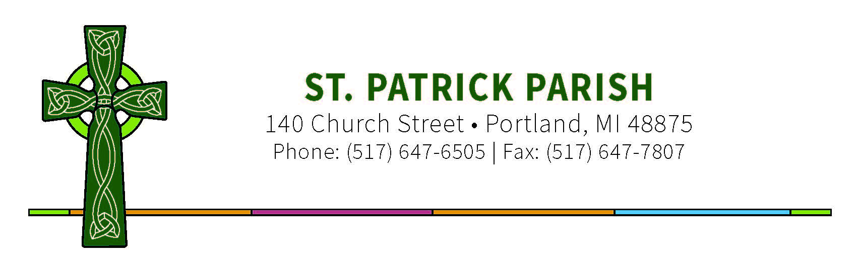

What are the requirements of the Church for being a Confirmation Sponsor?

- A Sponsor must be someone other than a parent of the Confirmation Candidate.
- A Sponsor must have received the Sacraments of Baptism, Confirmation, and Holy Eucharist.
- A Sponsor must be at least 16 years of age and may be male or female regardless of the gender of the candidate.
- A Sponsor must be leading a life in harmony with the faith and the role to be undertaken; therefore, if married, must be married in the Church and if single, must be striving to live a chaste life and therefore cannot be living with a person outside of marriage.
- A Sponsor must be a practicing Catholic, registered in a parish, who regularly attends Mass on Sundays and Holy Days and receives the Holy Eucharist.
- Be close enough in geography as to be able to maintain appropriate contact with the candidate before and after Confirmation.
- Attend and present the Candidate to the Bishop during the Confirmation Rite.

What is the role of a Confirmation Sponsor?
Just as sponsor for baptism takes upon himself/herself the responsibility of helping the newly baptized person mature in the living a Christian life and offers his or her own life and practice of the faith as an example of faith, prayer and service within the Catholic Church, the Sponsor for Confirmation continues that work for the person who is to be confirmed. The Sacrament of Confirmation also creates a strong spiritual bond between the one who is confirmed and the sponsor. The sponsor should be committed to trying to be a part of the confirmandi’s life by
presence and prayer always realizing that a sponsor’s prayers for that person are
especially efficacious before Almighty God. One’s “yes” to be a sponsor for Confirmation is
not just a “yes” to the candidate, but also a serious commitment to God in taking on this
obligation.

