St. Patrick Parish
Faith Formation Ministry
140 Church St.
Portland, MI 48875
517-647-6505 Ext. 419
MondayNightFaithFormation
April 2021

Month of the Holy Eucharist
This tradition has developed because Easter Sunday often falls in April, and when it does fall in March, the Easter season continues through April. In essence, April is a month of Easter, and during the Easter celebration we remember the Eucharistic sacrifice Christ gave us and the baptism in the Holy Spirit, which would come from Jesus’ resurrection.
This month I challenge the students to send in pictures of something the represents the Eucharist. This can be a picture of their First Communion, of some bread/wine, a gift received, something that represents the Holy Spirit, really anything. Any student or parent that sends in a picture will receive a free Slushie card. I only sent out one Slushie card last month and have plenty more to send.

Courage
“Be strong in our faith and witness to Jesus, stand up for what is right”. Parents are to teach and challenge their children this throughout the month. However you choose to reward them for practicing this is up to you. If you contact me that your children were “caught in the act” displaying this, I will send them a free Slushie card.

First Eucharist Preparation
Students should finish up the second part of “Signs of Grace, You Are Loved” this month. Be sure to turn in the certificate of completion when finished. All Mass celebrations have been scheduled in May and confirmation for dates have been sent out. If there is an issue with any dates scheduled, contact me right away. Final details for the Mass will be sent out later. Please be aware of the restrictions we are to follow. As of now, only parents and siblings can attend. If things change, I will let parents know.

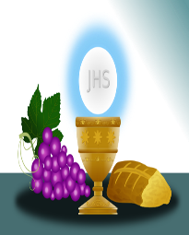

Jesus said, “Whoever comes to me will never hunger.
Whoever believes in me will never thirst.”

Confirmation Information
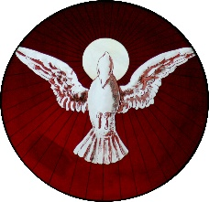
Students should be working on finishing up the online “Chosen” Program. When your student finishes up the lessons, contact me so I can print out their certificate of completion. All Mass celebrations have been scheduled. If there are any conflicts with any dates scheduled, contact me right away. Final Confirmation Celebration Mass details will be sent out later. Please be aware of the restrictions we are to follow. As of now, only parents and Sponsors are allowed to attend. If things change, I will let parents know. Let’s pray they do in time.

Service Project for April
This month’s service project will be for students to share their time and talents with others. Maybe it’s helping someone Spring clean their house or your own house, fresh coat of paint for your house, rake up the yard, plant flowers, pick up trash along the road or in parks, etc. Really anything that helps the world look better or brighten someone’s day. Send in pictures of their shared time taking place. Any pictures sent in will be rewarded with a free Slushie card. Last month I only sent out one Slushie card and I have plenty more to give out.

“They have taken the Lord from the tomb, and we don’t know where they put him.”
(John 20:1-9)

April Birthdays to Celebrate

2nd-Paxton Fox 11th-Lauren Spitley
3rd-Charleigh Thelen 17th-Gillian Pung
3rd-Grayson Graef 18th-Chase Hoppes
8th-Easton Hinds 24th-Evan Simon
10th-Olivia Setter 29th-Olivia Peake
11th-Raina Spitzley 30th-Payton Spedoske

