St. Patrick Parish
Faith Formation Ministry
140 Church St.
Portland, MI 48875
517-647-6505 Ext. 419
MondayNightFaithFormation
November 2022

Month for Holy Souls in Purgatory
The church commemorates all her faithful children who have departed from this life, but have not yet attained the joys of heaven. St. Paul warns us that we must not be ignorant concerning the dead, nor sorrowed, “even as others who have no hope… For the Lord Himself shall come down from heaven…and the dead who are in Christ shall rise.” The church has taught us to pray for those who have gone into eternity. I challenge families to talk about their loved ones who have passed. Discuss any memories you may have. Any student brings in a picture of a deceased family member will receive a prize. This can be done each Monday in November.

Generosity
“A person who is uncomplaining under pain and disappointment.” Parents are to teach and challenge their children this throughout the month. However you choose to reward them for practicing this is up to you. If you contact me that your children were “caught in the act” displaying this, I will send them a free Slushie card.

Service Project for November
This month’s service project will be for students to donate to the food bank. As a family you are to gather food and drop it off in church anytime during the month. Attached is a list of acceptable food item broken down by grade level. This helps in gathering a variety of items. With this challenge, the class that donates the most will be rewarded with their choice. Boxes are located in the back of the church. Be sure to place your donations in the correct grade level box for your student to get credit for their class.
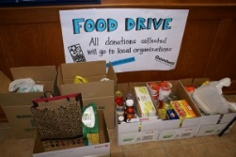

We Gather Together
On the revised calendar, our first Mass together will be Tuesday, November 1st at 6:00 pm. This takes place of classes on Monday, October 31st (Halloween). This Mass is All Saints Day and a Holy Day of Obligation. This Mass counts as class time for that week, so with your best efforts, please make it to this Mass. The class that has the most in attendance will be rewarded with their choice.

Also noted on the revised calendar, Nov. 7th classes are canceled due to a conflict. Then on Monday, Nov. 28th we will gather at the end of class time (7:30pm) in the church to pray the Rosary together. The students will need to be picked up from church this night at the regular time (8:00pm). A reminder will be sent out and students are to bring a Rosary from home, if possible.

First Reconciliation Preparation
All second-grade parents should have received information regarding your child’s preparation for receiving the Sacrament. Students should also be on week #4 in the “Signs of Grace: You Are Forgiven” online program. If you are having any issues with this, please contact me right away. In the past Father has scheduled a couple of dates for the children to receive Reconciliation, we are still working this out. The plan is to complete this between the two preparation online programs, so hopefully sometime in January. You will receive all information needed in time for marking it on your calendars.

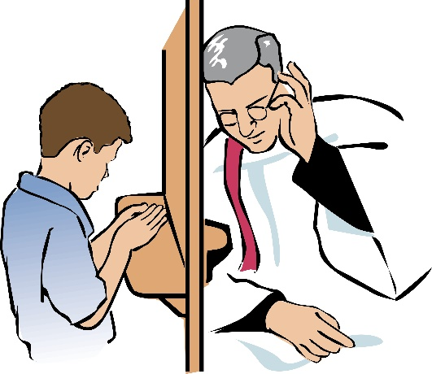
Forgiveness is the foundation for Reconciliation

Confirmation Information
Mark your calendars now! The Diocese of Grand Rapids has our Parish scheduled for Confirmation celebration on Sunday, May 7th , 2023 at 3:00 pm. More information will be sent out later.

“Let us give thanks to the Father, who has made you fit to share in the inheritance of the holy ones in light.” (Colossians 1:12-20)

November Birthdays to Celebrate
16th-Garth Pline
22nd -Klarie Keilen
20th- Mr. Dave Chislea
25th -Branlun Simon
27th- Alyssa Diffin

