St. Patrick Parish
Faith Formation Ministry
140 Church St.
Portland, MI 48875
517-647-6505 Ext. 419
MondayNightFaithFormation
November 2023

Month for Holy Souls in Purgatory
The church commemorates all her faithful children who have departed from this life but have not yet attained the joys of heaven. St. Paul warns us that we must not be ignorant concerning the dead, nor sorrowed, “even as others who have no hope… For the Lord Himself shall come down from heaven…and the dead who are in Christ shall rise.” The church has taught us to pray for those who have gone into eternity. I challenge families to talk about their loved ones who have passed. Discuss any memories you may have and pray for them. Any student who brings in a picture of a deceased family member will receive a prize. This can be done each Monday in November. Remind your child it is their responsibility to find me for their prize.

Generosity
“A person who is uncomplaining under pain and disappointment.” Parents are to teach and challenge their children this throughout the month. However you choose to reward them for practicing this is up to you. If you contact me that your children were “caught in the act” displaying this, I will send them a free Slushie card.

Service Project for November
This month’s service project will be for students to donate to the food bank. As a family you are to gather food and drop it off in church anytime during the month. Attached is a list of acceptable food items broken down by grade level. This helps in gathering a variety of items. With this challenge, the class that donates the most will be rewarded with their choice. Boxes are in the back of the church. Be sure to place your donations in the correct grade level box for your student to get credit for their class.
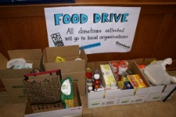

All Saints Day Mass Challenge
All Saints Day and a Holy Day of Obligation will take place on Wednesday, Nov. 1st at 6:00pm. This Mass will count as a “makeup” day your student may have missed will or will miss in the future. So, if your student has missed or will miss more than three classes due to practices, games, etc., this will give them one class back. Notify me that your student attended this Mass to get a “makeup” day credit.

First Reconciliation Preparation
All second-grade parents should have received information regarding their child’s preparation for receiving the Sacrament. Students should also be working on the “Signs of Grace: You Are Forgiven” online program. If you are having any issues with this, please contact me right away. In the past Father has scheduled a couple of dates for the children to receive Reconciliation, we are still working this out. The plan is to receive this Sacrament between the two preparation online programs, so hopefully sometime in January. You will receive all the information needed in time for marking it on your calendars.

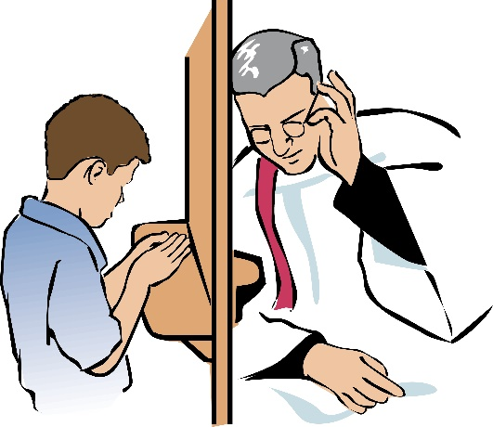
Forgiveness is the foundation for Reconciliation

Confirmation Information
Mark your calendars now! The Diocese of Grand Rapids has our Parish scheduled for Confirmation celebration on Sunday, April 28 , 2024 at 3:00 pm. More information will be sent out later. Families will receive most of this information from me.

“Let us give thanks to the Father, who has made you fit to share in the inheritance of the holy ones in light.” (Colossians 1:12-20)

November Birthdays to Celebrate
16th-Garth Pline
20th- Mr. Dave Chislea
22nd -Klarie Keilen
27th- Alyssa Diffin

