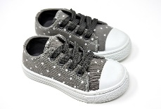

Did You Know?
Most people throw away their used sneakers every 125-200 days without ever thinking about recycling. Since sneakers are manufactured with materials that are not biodegradable, they remain in landfills or are incinerated, which leads to toxic chemicals in our air and soil.
The process of manufacturing sneakers produces large amounts of CO2 which contributes to the serious effects of climate change and global warming. Recycling and reusing sneakers keeps sneakers out of landfills, reduces the need for manufacturing new shoes and sneakers, and supports a growing circular economy.

Recycle Sneakers
At GotSneakers, we’re making it socially and financially rewarding to contribute to a circular economy with our FREE sneaker recycling programs for individual sellers and organizations of all types and sizes. When you join our sneaker recycling community, you will be making a global impact AND you will earn money for every pair of sneakers you contribute. This money will go to a charity of the student’s choice.

Students collect—We send out—Get a return
There will be a collection box in room 115 in the school on Monday evenings. There will be a box in the back of the church on the weekends. Be sure to drop off your unwanted sneakers at either location.
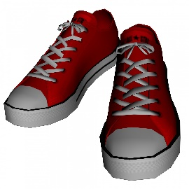

Kindly do not send in any non-athletic footwear including but not limited to dress shoes, heels, rain boots, sandals, slip-ons, water shoes, wedges,
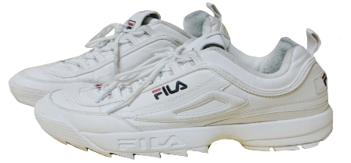
and work boots of any kind.

In the United States, at least 200 million pairs of shoes and sneakers end up in landfills each year.

Shoes in landfills can take 30 to 40 years to decompose.

Harmful chemicals are emitted into the soil and air which pollutes our surroundings.

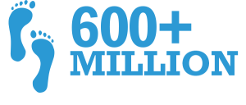

More than 600 million people worldwide don’t even own a pair of shoes.

What brands are wanted? Adidas, Asics, Brooks, Converse All-Star, Koka One One, Jordan, Nike, On, Under Armour, and many other athletic footwear brands.
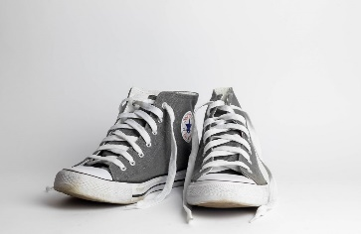
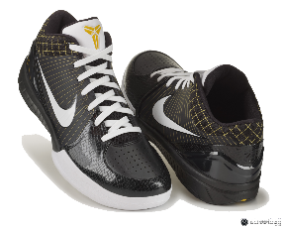
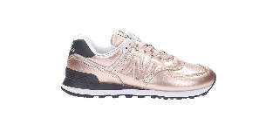
This Photo by Unknown Author is licensed under CC BY-NC

