St. Patrick Parish
Faith Formation Ministry
140 Church St.
Portland, MI 48875
517-647-6505 Ext. 419
MondayNightFaithFormation
January 2024

Month of the Holy Name of Jesus
January is dedicated to the Holy Name of Jesus. “In the name of Jesus every knee should bow, of those that are in heaven, on earth and under the earth” (Phil2:10). Christ’s name is chosen in heaven, and the Angel Gabriel announces it when he informs the Blessed Virgin of the incarnation: “Before thou shalt conceive in thy womb and shalt bring forth a son, and thou shalt call his name Jesus.” It is a name that has marvelous implications, for it means “Savior.” The very name bespeaks the magnitude of His mission, His infinite love, a love that will cause Him to offer Himself up for us. So, for this month, I challenge the students to find out what their name means. Many students may already know this from previous years. Students will get a prize when they bring in the meaning of their name.

Gratitude
“Showing thanks and appreciation by what someone did for you”. Parents are to teach and challenge their children this throughout the month. However, you choose to reward them for practicing, this is up to you. If you contact me that your children were “caught in the act” displaying this, I will send them a free Slushie card.

Service Project for January
This month’s service project will be for students to bring in donations for PSIC (Pregnancy Services of Ionia). The Knights of Columbus will be having a collection at church the weekend of January 20 and 21, so you can donate up until that weekend. You can bring donations to class on Monday or drop off items anytime the church is open. PSIC will except items such as diapers (especially sizes 5/6), baby wipes, blankets, formula, car seats, and clothing for infants and small children. See the bulletin for the specific items. There will be a box especially for your donations. Be sure to label your donations with the grade level of your child so their class gets the credit. The class with the most donations will be rewarded.

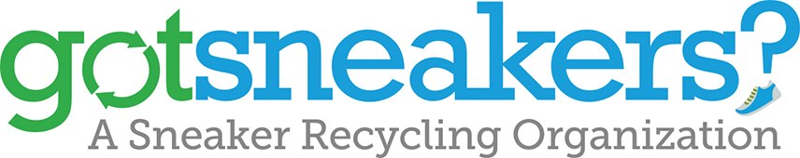

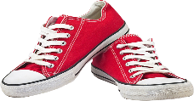
Refer to the flyer received in December with information on this recycling program. There will be a box in the school on Monday evenings and one in the church on the weekends to place your donation of sneakers. The return on this will go towards a charity of the students’ choice.
This Photo by Unknown Author is licensed under CC BY-NC

First Reconciliation Preparation
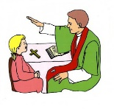
All second-grade parents will receive information regarding their preparation for receiving this Sacrament. There are two dates for this, both on Saturday, March 2nd OR March 9th at 10:00 am. You will only need to attend one of the dates. No need to sign up, just come when it best fits your schedule. All the details will be in the letter being sent out soon.

Forgive us for the times we have wronged others,
whether by ignorance, neglect, or intention.

“Give peace, O Lord, to those who wait for you, that your prophets be found true. Hear the prayers of your servant, and of your people Israel.” (Sirach 36:18)

January Birthdays to Celebrate
6th- Emma Snellenberger 21st- Wesley Pline
9th- Miss Ella Pohl 29th- Lauren Diffin
15th- Dominic Wendling 30th- Anthony Gross

