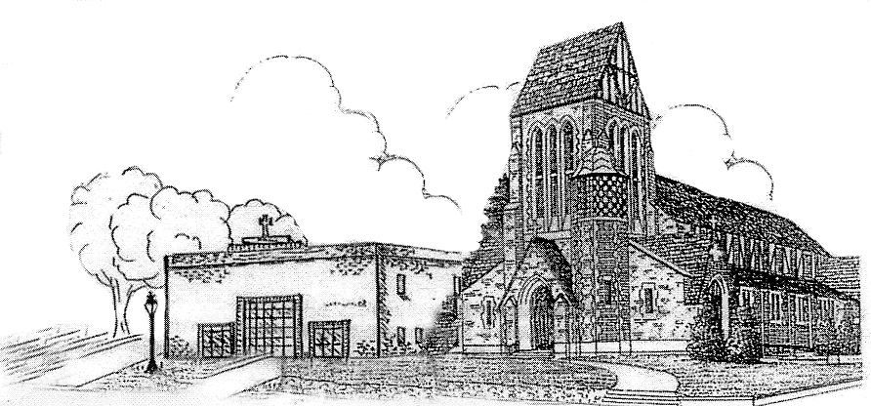St. Patrick Parish

Faith Formation Ministry

140 Church St.

Portland, MI 48875

517-647-6505 Ext. 419

**MondayNightFaithFormation**

**January 2025**

Month of the Holy Name of Jesus

January is dedicated to the Holy Name of Jesus. “In the name of Jesus every knee should bow, of those that are in heaven, on earth and under the earth” (Phil2:10). Christ’s name is chosen in heaven, and the Angel Gabriel announces it when he informs the Blessed Virgin of the incarnation: “Before thou shalt conceive in thy womb and shalt bring forth a son, and thou shalt call his name Jesus.” It is a name that has marvelous implications, for it means “Savior.” The very name bespeaks the magnitude of His mission, His infinite love, a love that will cause Him to offer Himself up for us. So, for this month, I challenge the students to find out what their name means. Many students may already know this from previous years. Students will get a prize when they bring in the meaning of their name.

Gratitude

**“Showing thanks and appreciation by what someone did for you”.** Parents are to teach and challenge their children this throughout the month. However, you choose to reward them for practicing, this is up to you. If you contact me that your children were “caught in the act” displaying this, I will send them a free Slushie card.

**Service Project for January**

This month’s service project will be for students to bring in donations for PSIC (Pregnancy Services of Ionia). The Knights of Columbus will be having a collection at church on the weekend of January 18 and 19, so you can donate until that weekend. You can bring donations to class on Monday or drop off items anytime the church is open. PSIC needs diapers and pull-ups sizes 3/4/6. See the bulletin for the specific items, if you wish to donate other items. There will be a box especially for your donations. No need to label your donations, just place them in the box in the back of church. If each family donated just one package, that would reach our goal of 30 packages.







Just to update you on this recycling program that we have stared over a year ago, we have earned $82.00. Be sure to keep sending in your old sneakers. You can still bring them on Monday evenings or drop them off in the back of the church. The return on this will go towards a charity of the students’ choice.



[This Photo](https://www.pngall.com/sneakers-png/) by Unknown Author is licensed under [CC BY-NC](https://creativecommons.org/licenses/by-nc/3.0/)

First Reconciliation Preparation

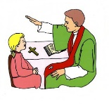All second-grade parents should have received information regarding their preparation for receiving this Sacrament. There are two dates for this, both on Saturday, January 25th or February 8th at 10:00 am. You will only need to attend one of the dates. No need to sign up, just come when it best fits your schedule. A reminder letter will be sent out closer to the date.

Forgive us for the times we have wronged others,

whether by ignorance, neglect, or intention.

***“Give peace, O Lord, to those who wait for you, that your prophets be found true. Hear the prayers of your servant, and of your people Israel.”* (Sirach 36:18)**

January Birthdays to Celebrate

 6th- Emma Snellenberger 21st- Wesley Pline

9th- Miss Ella Pohl 29th- Lauren Diffin

30th- Anthony Gross