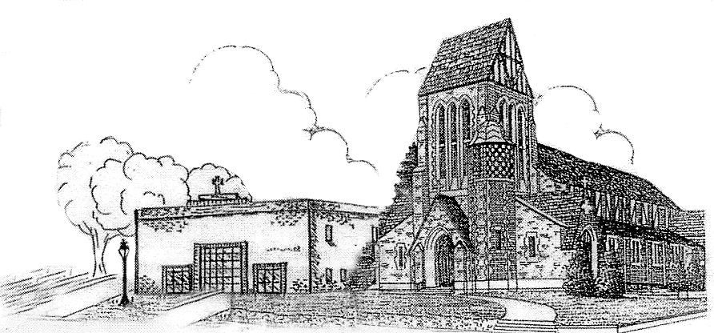St. Patrick Parish

Faith Formation Ministry

140 Church St.

Portland, MI 48875

517-647-6505 Ext. 419

**MondayNightFaithFormation**

**May 2025**

Month of Blessed Mother Mary

May is dedicated to the Blessed Mother which originated in Rome in the 18th century to counter immorality and infidelity among students at a college there. It has spread through most of the Latin Church now. Because the North American holiday of Mother’s Day fall in May, Catholics take this time to recall and try to emulate Mary’s role as mother. Therefore, devotion to Mary in the month of May focuses on Mary as a model for Christian mothers, and Mary’s everlasting chastity and purity, and her fidelity to God’s will.

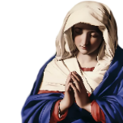

Patience

***“Someone’s ability to wait for something without agitation.”*** Parents are to teach and challenge their children throughout the month. However, you choose to reward them for practicing, this is up to you. If you contact me that your children were “caught in the act” displaying this, I will send them a free Slushie card.

**Service Project for May**

This month, students are to do something nice for their teacher(s). Help them clean the classroom or organize it, bring them flowers, their favorite soft drink, coffee, or water, their favorite candy bar, cookies, cake, or dessert, buy them lunch. Send me a picture of you and your teacher. Any picture that gets sent to me will earn you a free Slushie card.





Last Class Information

For the last class, students will be in the classroom for the first half hour. After that they will enjoy games and treats in the park, weather permitting. Please pick up your student in Alton Park at the end of the evening.

First Communion Information

Parents will receive information regarding the First Communion Retreat scheduled for Thursday, May 22nd in the Parish Hall. What an exciting time for you and your family to share in this Sacred Sacrament. A letter will go home with your student on Monday. Then you will receive an RSVP reminder which will help us to know how many will be in attendance for lunch and snacks. Watch for the reminder later this month.

Summer Challenge is Back

Students will have an opportunity to earn a free Slushie card if they bring in a bulletin from another Parish they have visited over the summer. Pin the bulletin on the bulletin board at the back of the church with your name on it. I will send you a free Slushie card. Easy peasy! This will begin in June. You can bring more than one too.

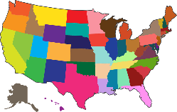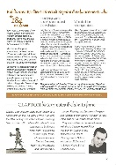

*“Bring your hand and feel the place of the nails, and do not be unbelieving but believing, alleluia.”*

(John 20:27)

May Birthdays to Celebrate



[This Photo](http://martinhumanities.com/2014/04/30/may-birthdays-happy-birthday/comment-page-1/) by Unknown Author is licensed under [CC BY-SA-NC](https://creativecommons.org/licenses/by-nc-sa/3.0/)

6th-Hannah Weber 11th- Mrs. Ann Miller

9th-Brady Keilen 12th-Jay Snellenberger

9th-Oakleigh Zimmer 17th-Crue Zimmer

11th-Lane Beard