St. Patrick Parish
Faith Formation Ministry
140 Church St.
Portland, MI 48875
517-647-6505 Ext. 419
MondayNightFaithFormation
September 2021

Month of Seven Sorrows of Mary
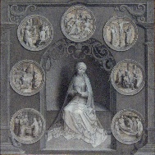
September is traditionally dedicated to the Seven Sorrows (or Dolours) of Mary, and the Feast of Our Lady of Sorrows falls in September. The Sorrows are the Prophecy of Simeon, the flight into Egypt, the loss of the Holy Child at Jerusalem for three days, meeting Jesus on his way to calvary, standing at the foot of the Cross, Jesus being taken from the Cross, and burial of Christ. This month I challenge the students to send in pictures of something the represents any of the Seven Sorrows. Any student or parent that sends in a picture will receive a free Slushie card.

Right Judgement
“One’s ability to make good decisions and follow the Ten Commandments.” Parents are to teach and challenge their children this throughout the month. However you choose to reward them for practicing this is up to you. If you contact me that your children were “caught in the act” displaying this, I will send them a free Slushie card.

Service Project for September
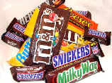
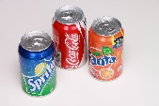
This month’s service project will be for students to do something nice for a friend. Being back in school and seeing friends is a great feeling. Send your friend a card or flowers, give them their favorite drink or candy, help them with homework, take them for ice cream, etc. Send in a picture of you and your friend and you both will be rewarded with free Slushie cards. A new year brings a lot more Slushie cards.

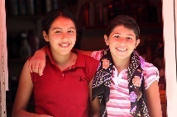

Faith Formation Classes
“Education is a family matter, parents and teachers must collaborate openly and constructively to form children in core values which enable them to face modern challenges”—Pope Francis.

As most of you are aware, classes will be conducted at home with parents this year. Registration forms are available on the children’s webpage, in the back of the church, and at the office. Students’ textbooks and packets are also available at the office and can be picked up anytime during office hours of T-F 9-4. Throughout the year you will receive these newsletters and other recourses. Plans are being made for meetings throughout the year with students/families/parents. This will give families a chance to voice their concerns and ask questions. The student packets explain more in detail how the year will look, so be sure to pick one up with the textbooks when turning in the fee.

“Give peace, O Lord, to those who wait for you, that your prophets be found true. Hear the prayers of your servant, and of your people Israel.” (Sirach 36:18)

Sacramental Information
For the Sacramental grades (2nd/8th), there are different programs that will provide this formation. Each program will begin later in the year. There is no extra cost for these programs. The second graders will use the online “Signs of Grace” program. This program has two parts to it; “You Are Forgiven” (Reconciliation) and “You Are Loved” (Communion). “You Are Forgiven” will begin in October, “You Are Loved” will begin next year (2022). Students will receive their First Reconciliation in early 2022. Students will receive their First Communion in the spring of 2022. The eighth graders will use the online “Chosen” program. This program will begin in early 2022 as well. Students will receive Confirmation in the spring of 2022. There are outlines for each program to help keep students on track. More information will come in plenty of time for you to prepare.

September Birthdays to Celebrate
3rd- Kayla Weber 17th- Jenna Pluff
4th- Zachary Edlund 19th- Ethan Cassel
8th- Barrett Spitzley 22nd- Olivia Russman
9th- Alaina Simon 22nd - Lola Russman
11th- Sawyer Rockey 23rd - Isadora Robydek
11th- Evan Keilen 23rd - Blake Weber
11th- Cassie Detzler 24th- Leo Wagner
11th- Drew Swanson 25th- Arlo Brown
14th- Brooke Keilen 29th- Carson Simon

